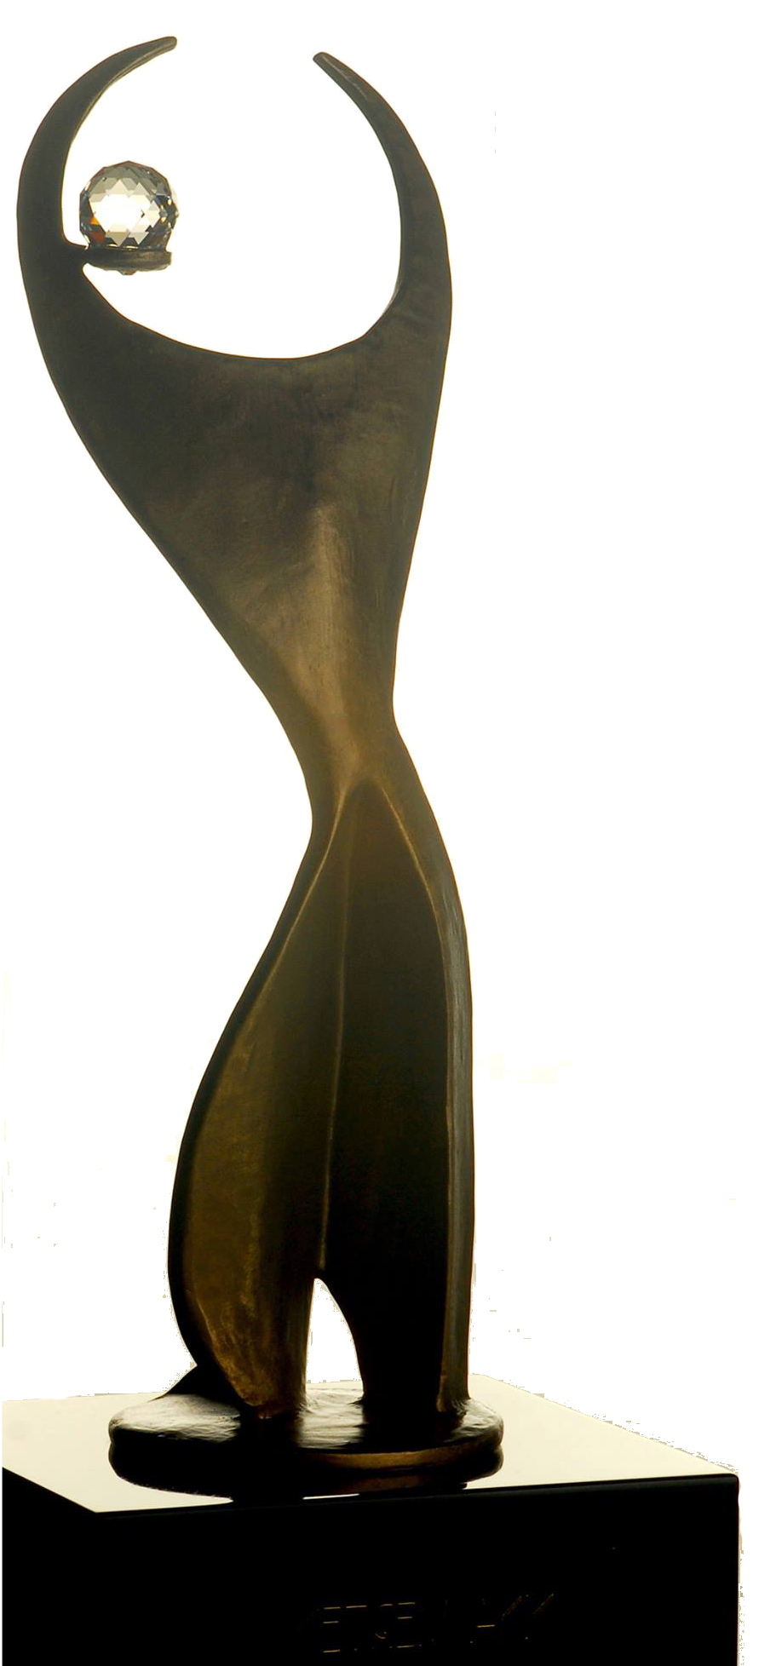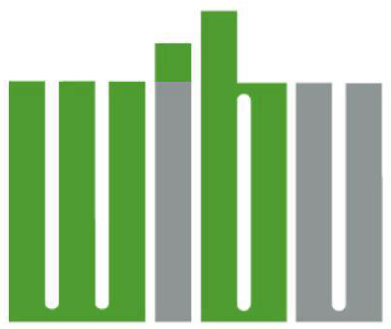 2018 ATHENA LEADERSHIP AWARD

The ATHENA Award, an honor awarded internationally, and presented locally by Women In Business Unlimited, honors individuals who strive toward the highest levels of personal and professional accomplishment, who excel in their chosen field, devote time and energy to their community in a meaningful way, and forge paths of leadership for other women to follow.

THE CRITERIA
ATHENA Leadership Award Nominees must meet each of the following three criteria:
- Demonstrate excellence, creativity and initiative in their business or profession;
- Provide valuable service to improve the quality of life for others in the Muncie-Delaware County community;
- Actively assist women in achieving their full leadership potential

QUALIFICATIONS
- ATHENA Leadership Award Nominees may represent either the profit or not-for-profit sector.
- Previous ATHENA Leadership Award Recipients are not eligible for nomination, however past nominees may be nominated again.
- There is no minimum or maximum age qualification that must be met by ATHENA Leadership Award Nominees.

COMPLETING THE FORM
- Nominators are strongly encouraged to work closely with nominees to ensure complete
and accurate nominations.
- Nominations for the ATHENA Leadership Award must be submitted using this nomination form and format.
- You may include supporting documents (articles, testimonials, letters of support, etc) with your
completed nomination form. Please do not include photos.
- Nominee's current résumé must accompany nomination form.

SELECTION PROCESS
A Selection Committee, made up of a diverse group of community leaders who do not personally know the nominees, will review all nominations and select the ATHENA Leadership Award Recipient. The recipient will be announced at the ATHENA Luncheon on Wednesday November 28, 2018.

SUBMIT NOMINATIONS
The deadline for submission is September 21, 2018. You may submit your nomination by mail, email, or personal delivery. Mail: Women in Business Unlimited, PO Box 556 Muncie, IN 47308 (must arrive by September 21). Email: ATHENA@wibumuncie.org. Hand Deliver: Drop off to Tara Whitehead at Mid-West Metal Products, 3142 S. Cowan Rd., Muncie, IN 47302

Date:

NOMINEE

Name:

Home Address:

City, State, Zip:

Phone:

Email:

Company/Organization:

Title/Position:

Business Address:

City, State, Zip:

Work Phone:

Business Email:

NOMINATOR

Name:

Company/Organization:

Business Address:

City, State, Zip:

Phone:

Email:

I. PROFESSIONAL LEADERSHIP
Provide specific examples of how the nominee has demonstrated excellence, creativity and initiative in their business or profession.

II. COMMUNITY LEADERSHIP
Provide specific examples of how the nominee provides valuable service to improve the quality of life for others in their community. Include type and length of service in civic and service organizations and initiatives.

III. PERSONAL LEADERSHIP/MENTORSHIP
Provide specific examples of how the nominee has actively assisted women in achieving their full leadership potential and/or demonstrated support for their personal and professional advancement.

ADDITIONAL INFORMATION PERTAINING TO CRITERIA
Include any additional information you feel is important for consideration of your nominee. Include awards, honors, publications, articles and/or testimonials that demonstrate service to their profession, community, and most importantly, aspiring and established women leaders.

