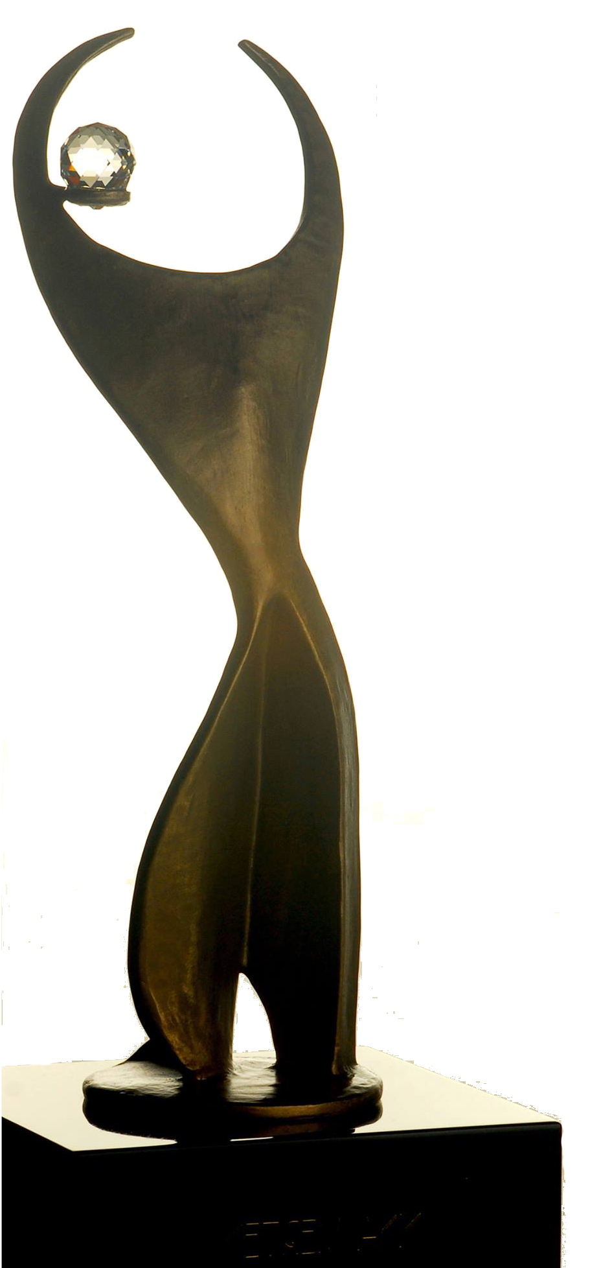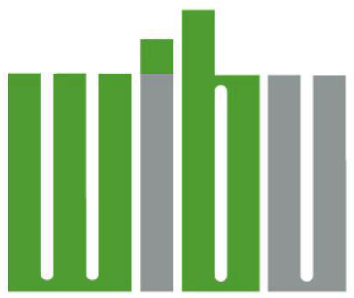 2018 ATHENA YOUNG PROFESSIONAL LEADERSHIP AWARD

The ATHENA Award, an honor awarded internationally, and presented locally by Women In Business Unlimited, honors individuals who strive toward the highest levels of personal and professional accomplishment, who excel in their chosen field, devote time and energy to their community in a meaningful way, and forge paths of leadership for other women to follow.

THE CRITERIA
ATHENA Young Professional Leadership Nominees are emerging women leaders who meet each of the following criteria:
• Demonstrates excellence, creativity and initiative in her business or profession
• Provides valuable service to improve the quality of life for others in her community
• Clearly serves as a role model for young women both personally and professionally

QUALIFICATIONS
- ATHENA Young Professional Leadership Award Nominees are 40 years of age or younger.
- ATHENA Young Professional Award Nominees may represent either the profit or not-for-profit sector.
- Previous ATHENA Young Professional Leadership Award Recipients are not eligible for nomination, however past nominees may be nominated again.

COMPLETING THE FORM
- Nominators are strongly encouraged to work closely with nominees to ensure complete
and accurate nominations.
- Nominations must be submitted using this nomination form and format.
- You may include supporting documents (articles, testimonials, letters of support, etc) with your
completed nomination form. Please do not include photos.
- Nominee's current résumé must accompany nomination form.

SELECTION PROCESS
A Selection Committee, made up of a diverse group of community leaders who do not personally know the nominees, will review all nominations and select the ATHENA Young Professional Leadership Award Recipient. The recipient will be announced at the ATHENA Luncheon on Wednesday, November 28, 2018.

SUBMIT NOMINATIONS
The deadline for submission is September 21, 2018. You may submit your nomination by mail, email, or personal delivery. Mail: Women in Business Unlimited, PO Box 556 Muncie, IN 47308 (must arrive by September 21). Email: ATHENA@wibumuncie.org. Hand Deliver: Drop off to Tara Whitehead at Mid-West Metal Products, 3142 S. Cowan Rd., Muncie, IN 47302

Date:

NOMINEE

Name:

Home Address:

City, State, Zip:

Phone:

Email:

Company/Organization:

Title/Position:

Business Address:

City, State, Zip:

Work Phone:

Business Email:

NOMINATOR

Name:

Company/Organization:

Business Address:

City, State, Zip:

Phone:

Email:

I. PROFESSIONAL LEADERSHIP
Provide specific examples of how the nominee is an emerging leader in their chosen field.

II. COMMUNITY LEADERSHIP
Provide specific examples of how the nominee provides valuable service to improve the quality of life for others in their community. Include type and length of service in civic and service organizations and initiatives.

III. PERSONAL LEADERSHIP/MENTORSHIP
Provide specific examples of how the nominee has actively assisted women in achieving their full leadership potential and/or demonstrated support for their personal and professional advancement.

ADDITIONAL INFORMATION PERTAINING TO CRITERIA
Include any additional information you feel is important for consideration of your nominee. Include awards, honors, publications, articles and/or testimonials that demonstrate service to their profession, community, and most importantly, aspiring and established women leaders.

